 | Pimpri Chinchwad Education Trust’s  Pimpri Chinchwad College of Engineering  (PCCoE)  (An Autonomous Institute)  Affiliated to Savitribai Phule Pune University(SPPU) ISO 21001:2018 Certified by TUV | 
Course: DevOps Laboratory | Code: BIT26VS01
Name: Amar Vaijinath Chavan | PRN: 124B2F001
Assignment 15: Prepare a Case Study on Ansible and demonstrate its application.

Aim: To prepare a comprehensive case study on Ansible automation and demonstrate its application
by configuring a remote EC2 server using Ansible Playbooks.

Objectives:
- To understand Ansible’s agentless architecture and its core components.
- To perform a real-world case study on the impact of Ansible in enterprise DevOps.
- To demonstrate the automation of software installation and configuration management on a remote cloud instance.

1. Theory & Case Study

1.1 Overview of Ansible
Ansible is an open-source IT automation engine that automates cloud provisioning, configuration management, application deployment, and intra-service orchestration. Unlike other tools, it is agentless, meaning it does not require any software to be installed on the managed nodes; it connects over standard SSH.
1.2 Key Components
- Control Node: The machine where Ansible is installed and from which commands are run.
- Managed Nodes: The target servers (like AWS EC2 instances) being managed by Ansible.
- Inventory: A file that defines the list of managed nodes and their logical groupings.
- Playbooks: YAML files that describe the desired state of your systems through a series of "tasks".
- Modules: Small programs that Ansible pushes to nodes to perform specific actions (e.g., apt, service).
1.3 Case Study: Amelco Financial Services
Background: Amelco, a provider of betting and financial market solutions, faced challenges managing over 400 VMware nodes across diverse Linux environments. Manual deployments were inconsistent, slow, and prone to downtime. Implementation: Amelco migrated to an agentless automation framework using Ansible and Ansible Tower.
Results:
- Efficiency: Deployment times were reduced from weeks to days, and eventually to single-click releases.
- Consistency: Automated playbooks ensured a single source of truth across development, test, and production environments.
- Self-Service IT: Empowered non-technical teams to trigger automated workflows, reducing reliance on senior sysadmins.

2. Practical Procedure / Steps
Step 1: Environment Preparation (IAM & EC2)
- An IAM user Ansible-Admin was created with AmazonEC2FullAccess permissions to manage cloud resources programmatically.
- A new EC2 instance named ansible-lab-server was launched in the eu-north-1 (Stockholm) region using an Ubuntu 24.04 LTS AMI and a t3.micro instance type.
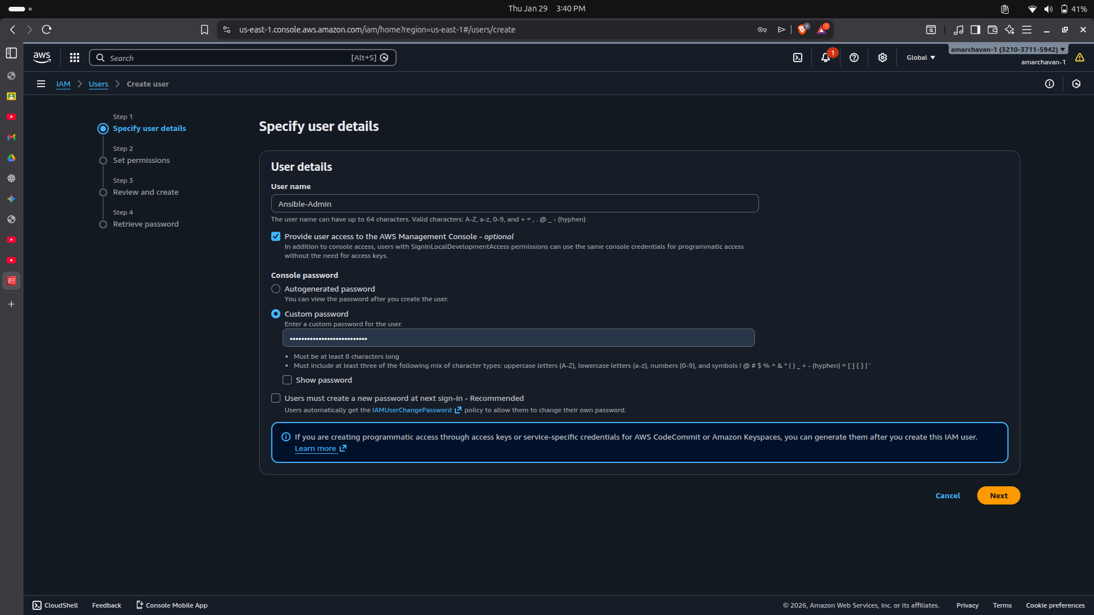
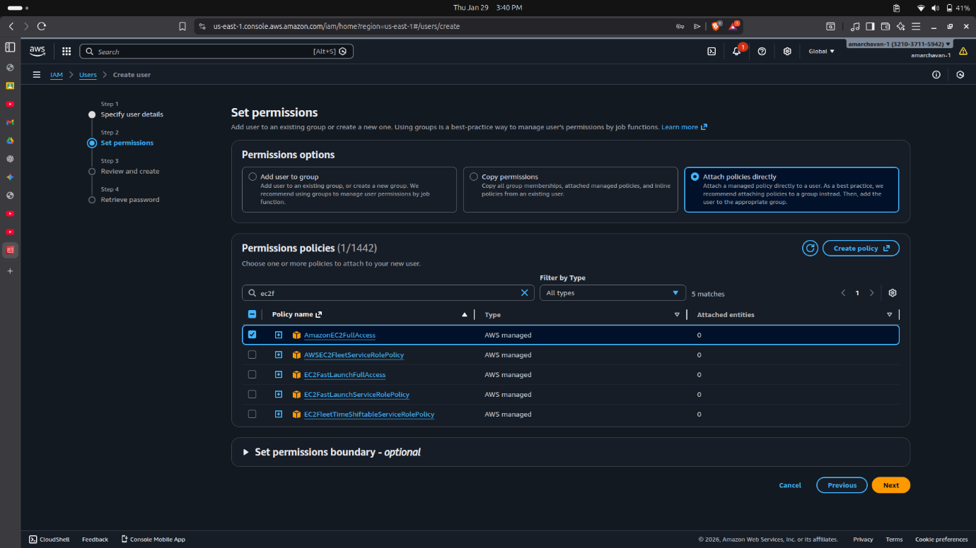
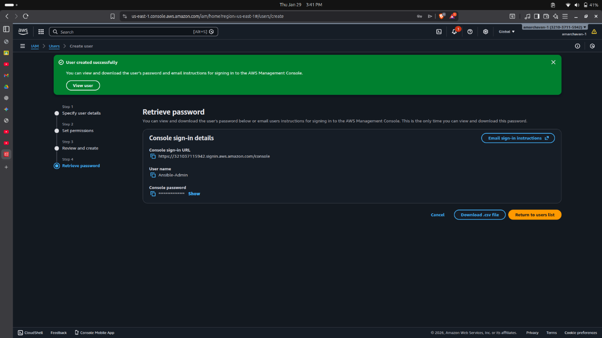
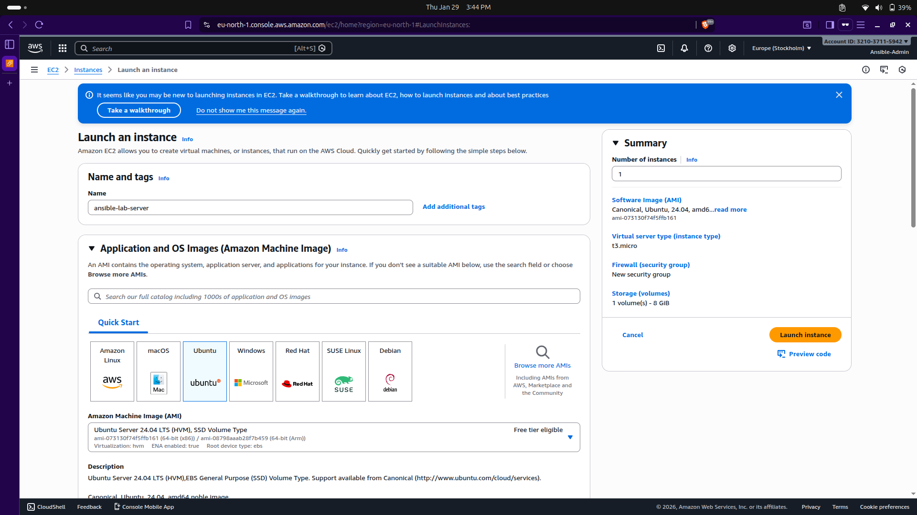

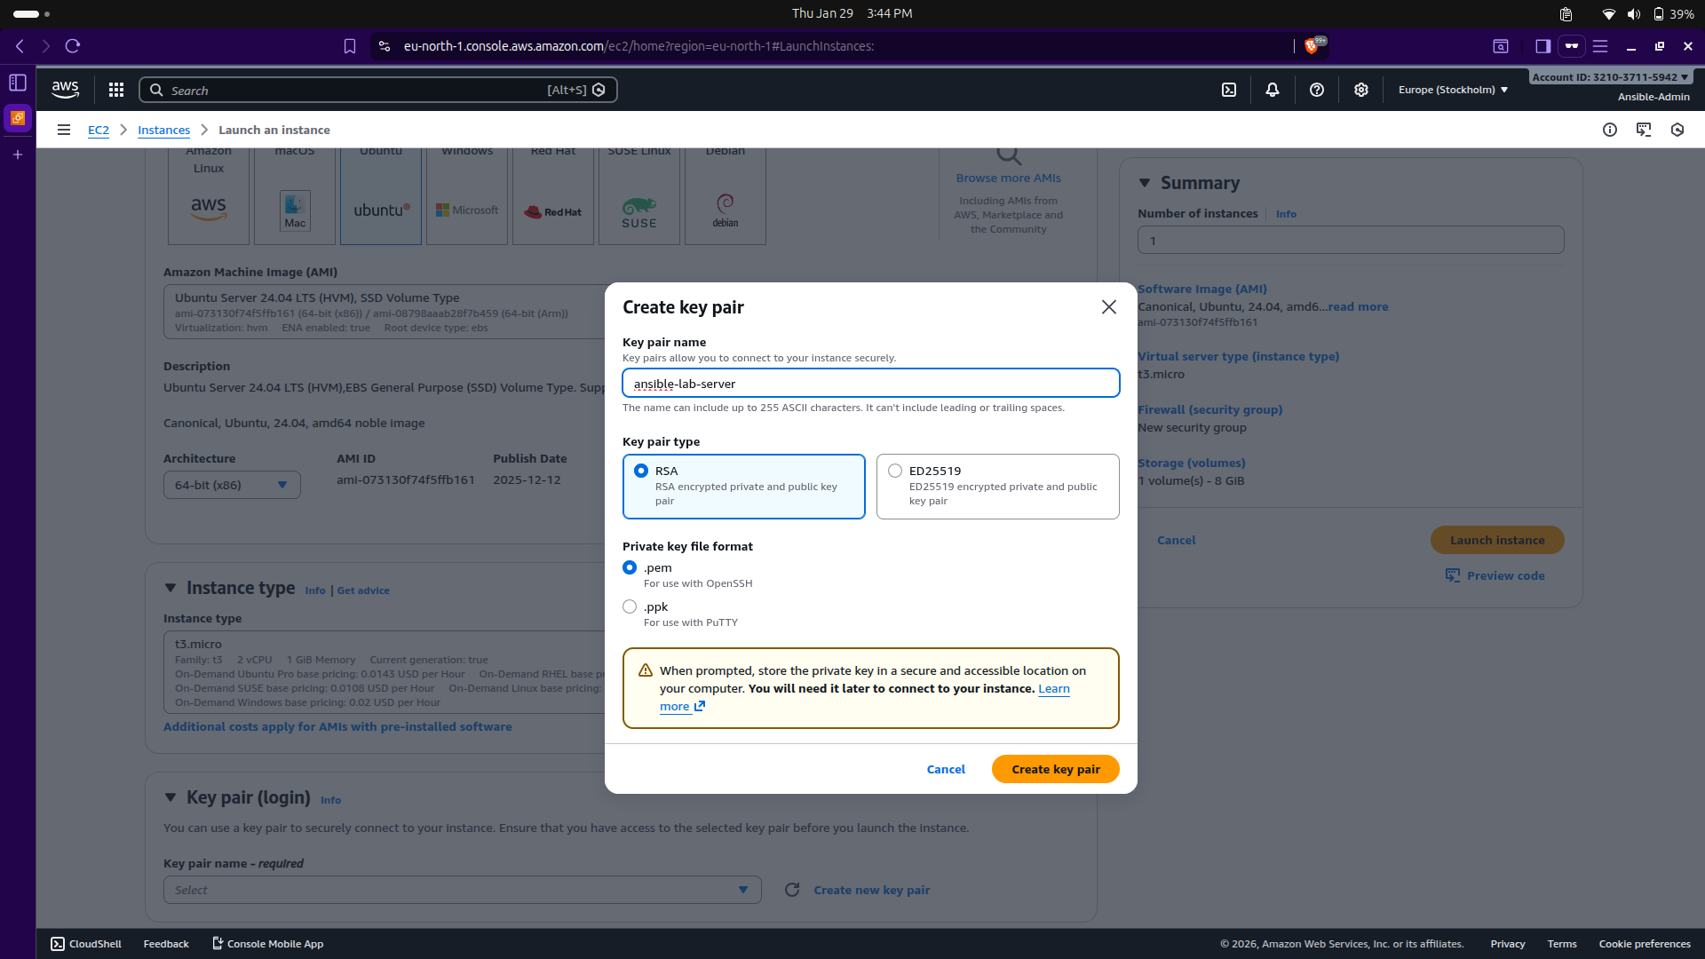
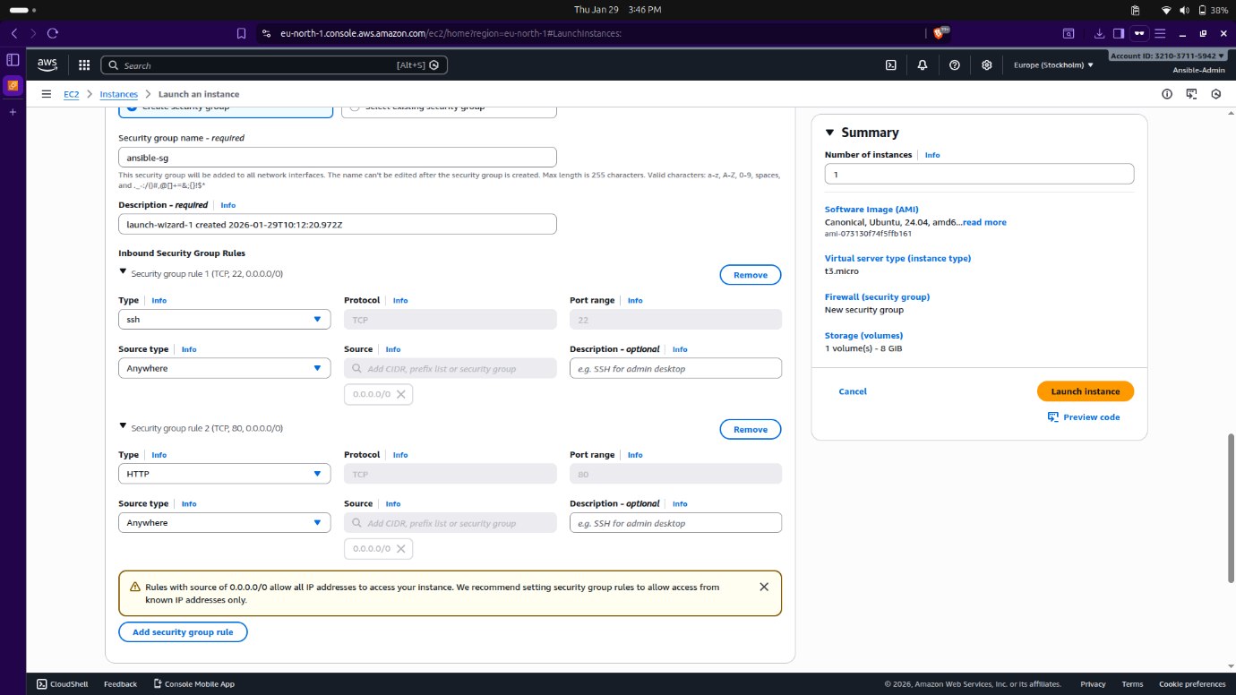
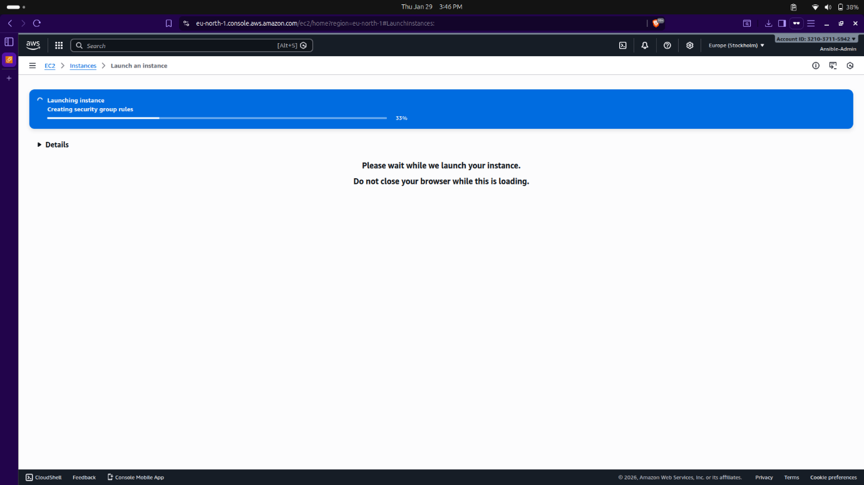

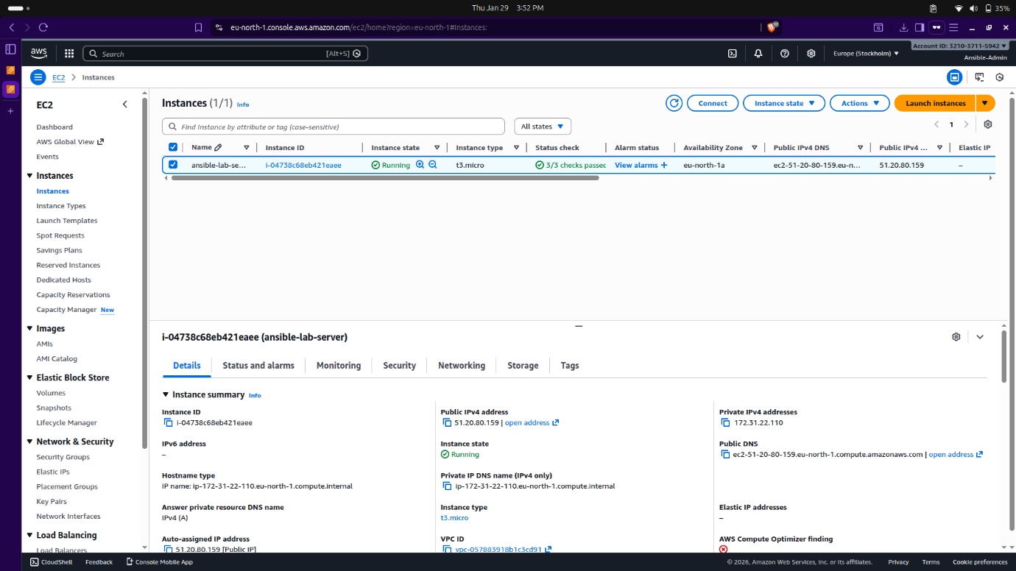

Step 2: Ansible Installation on Control Node
- On the local Ubuntu machine (Control Node), a Python virtual environment was used to install Ansible via pip install ansible.
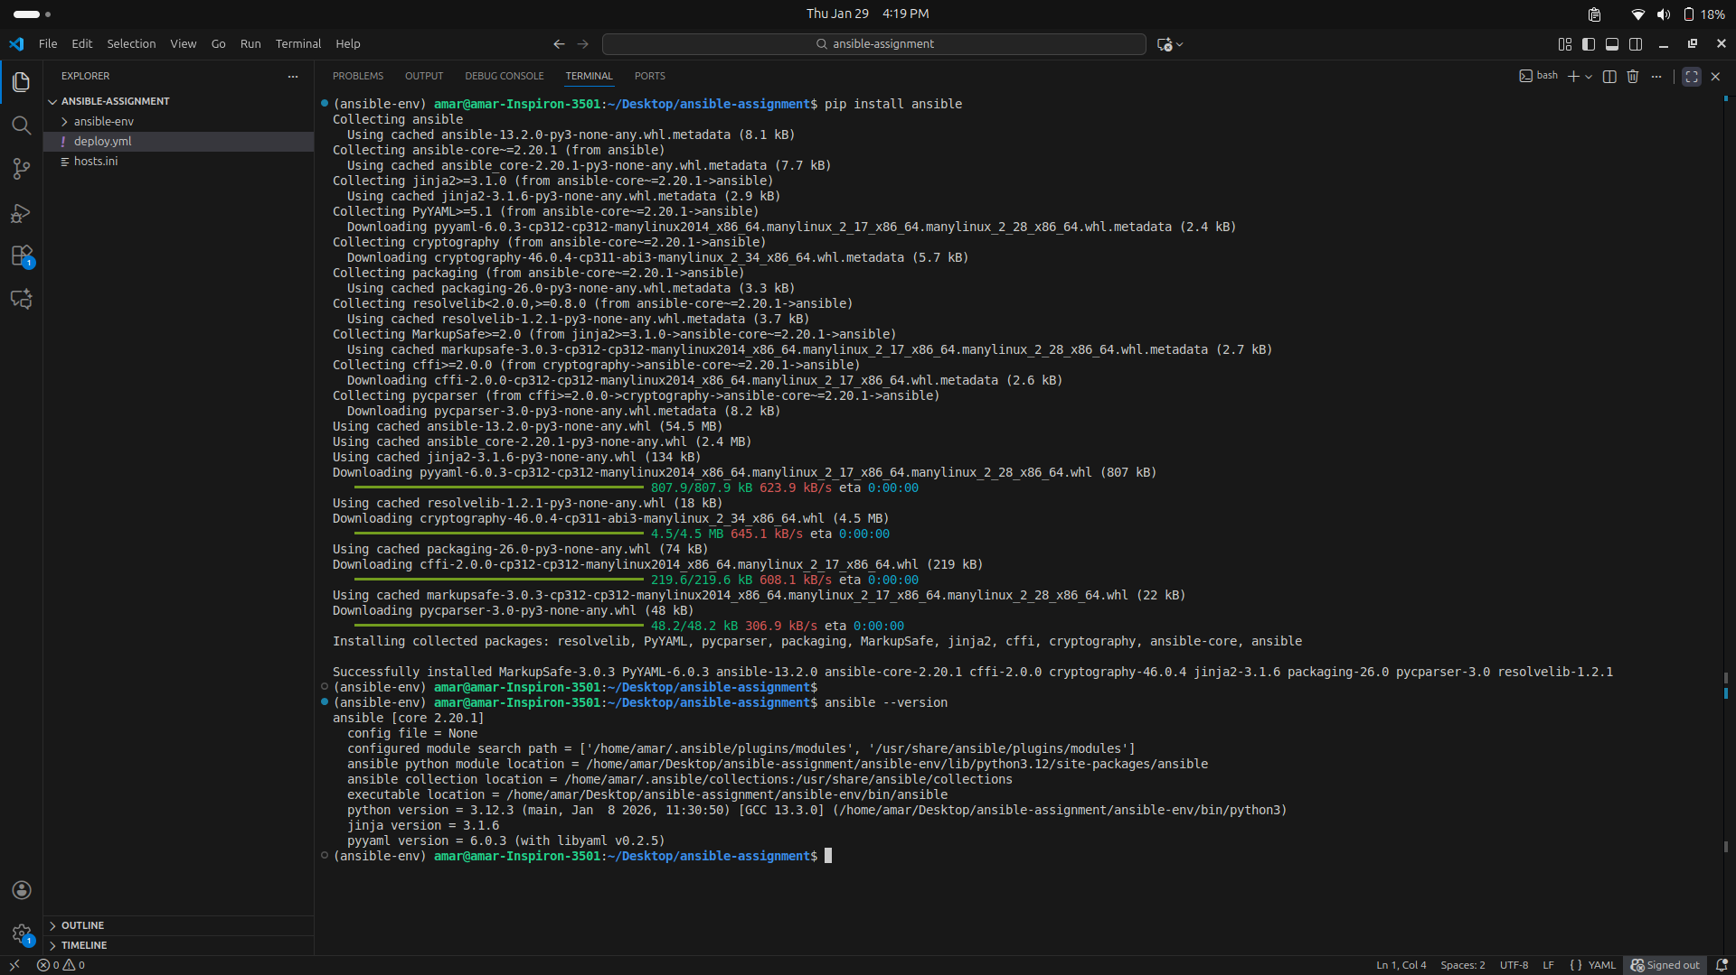

Step 3: Configuration & Inventory Setup
- An ansible.cfg file was created to disable host key checking and specify the inventory file.
- A hosts.ini file was configured with the Public IP of the managed node (51.20.80.159), the remote user (ubuntu), and the path to the private key file.

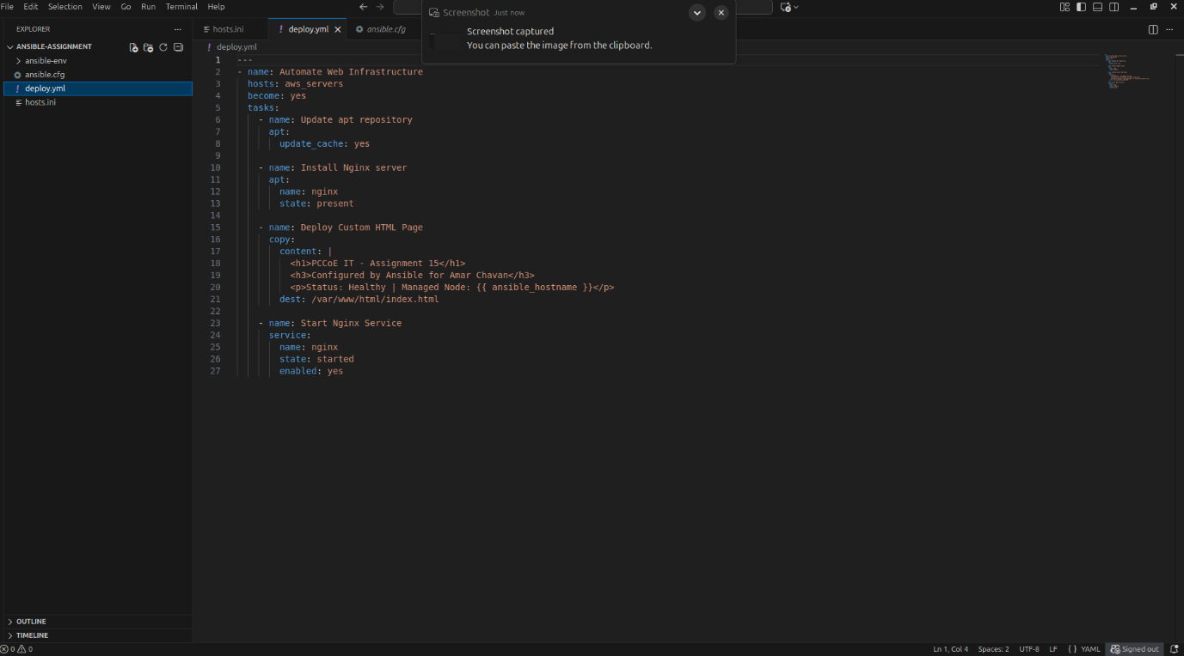
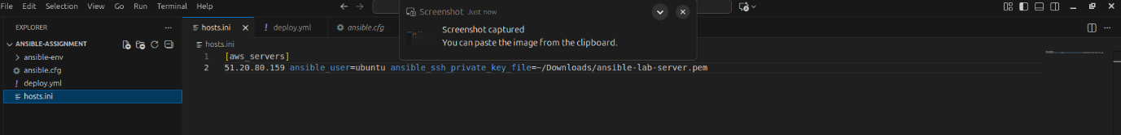

Step 4: Creating and Running the Playbook
- A playbook named deploy.yml was written to automate the following tasks:
  - Update the apt repository cache.
  - Install the Nginx web server.
  - Deploy a custom HTML page containing "PCCoE IT - Assignment 15".
  - Ensure the Nginx service is started and enabled on boot.
- Execution: The command ansible-playbook -i hosts.ini deploy.yml was executed.
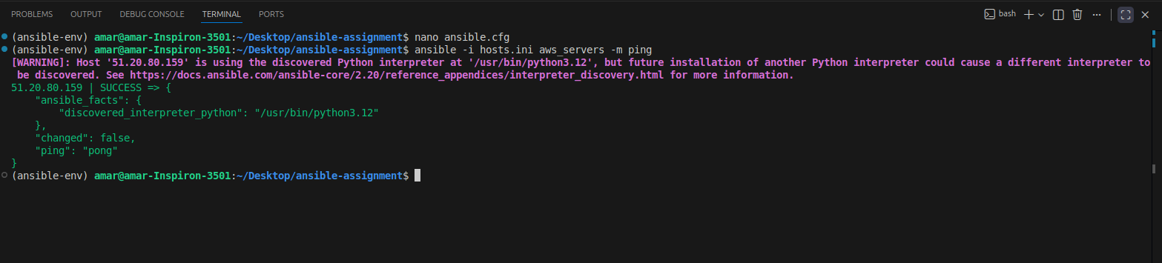
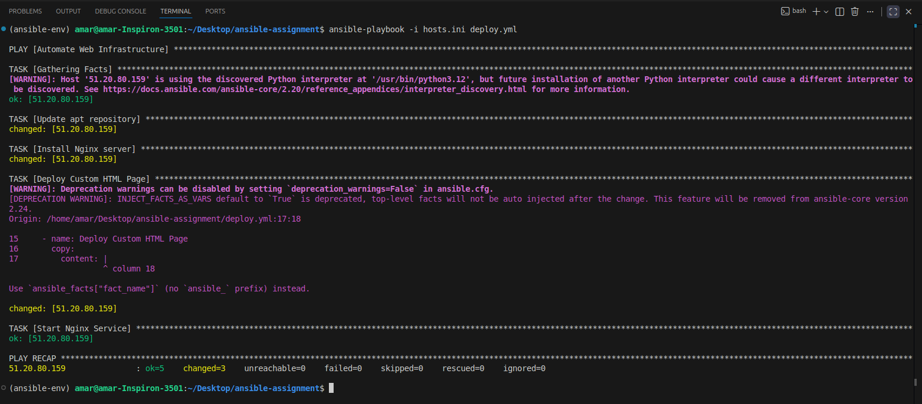


Conclusion
The successful completion of Assignment 15 confirms that Ansible is a superior choice for configuration management due to its simplicity, human-readable YAML syntax, and agentless nature. Through the Amelco case study, the enterprise value of automation—including consistency across environments and significantly reduced deployment times—was clearly identified. The practical demonstration showed how a single Ansible Playbook could orchestrate complex software installations and configurations on a remote AWS EC2 instance securely and efficiently. By implementing Infrastructure as Code (IaC) principles, we achieved a repeatable and reliable deployment process that eliminates manual errors, forming a critical component of modern professional DevOps pipelines.

